Sentle Ts’ita-202322646

Software Design Document
Moderated Learning Management System

1. Introduction
This document continues from the SRS, the stakeholder analysis and the use case model completed in week 2. It turns the requirements (FR-01 to FR-18 and NFR-01 to NFR-08) into an architecture, a class design, behavioural models and a database design for the LMS.

2. Architecture

2.1 Architectural style: layered architecture
The system uses a four-layer architecture. Each layer calls only the layer directly below it.
Layer | Responsibility | Main elements
Presentation | Shows menus, reads input, shows messages. One menu for each role. | User, Student, Lecturer, HeadOfDepartment, Administrator (showMenu)
Business (service) | Holds the rules: login, effective deadline, late penalty, moderation, audit logging. | AccountService, AssignmentService, SubmissionService, ModerationService, LatePenaltyStrategy
Data access | Hides SQL from the rest of the system. Uses parameterised queries. | Repository, SqliteRepository, EntityMapper
Storage | Keeps data after the system is closed. | SQLite database file
The domain classes (User, Course, Assignment, Extension, Submission, Department, AuditLogEntry) are shared by all layers.

2.2 Component diagram
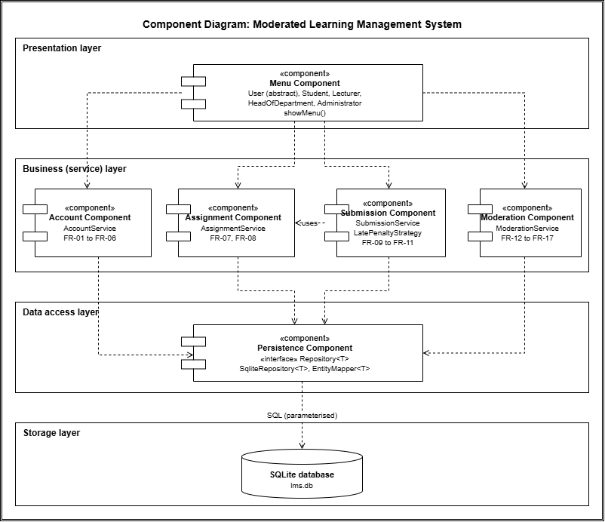

2.3 Design rationale
- Offline and simple (NFR-04). The layers all run in one process on one computer, so no network is needed. The Principal asked for a simple system, and a layered design is easy to explain and to maintain.
- Rules in one place. The late penalty, effective deadline and moderation rules are in the business layer only. A change to a rule (such as CR1, class-wide extensions) touches the service layer and not the menus or the database.
- Security (NFR-03). Only the data access layer talks to SQLite, so every query is parameterised and passwords are always hashed before they are saved.
- Testability. The services depend on the Repository interface, so unit tests can use a fake repository without a database.

2.4 Alternatives rejected
Alternative | Why it was rejected
Model–View–Controller | MVC suits interfaces with several views that update when the model changes. This system has a console interface with simple menus, so a controller and view layer would add classes without adding value.
Client–server | It needs a server and a network. The IT officer said the school has old computers and unreliable internet, and NFR-04 requires full offline use.
Single-layer program with SQL in the menus | It is quick to write, but the rules would be repeated in many places, SQL injection risk would grow, and the code could not be unit tested.

3. Class design
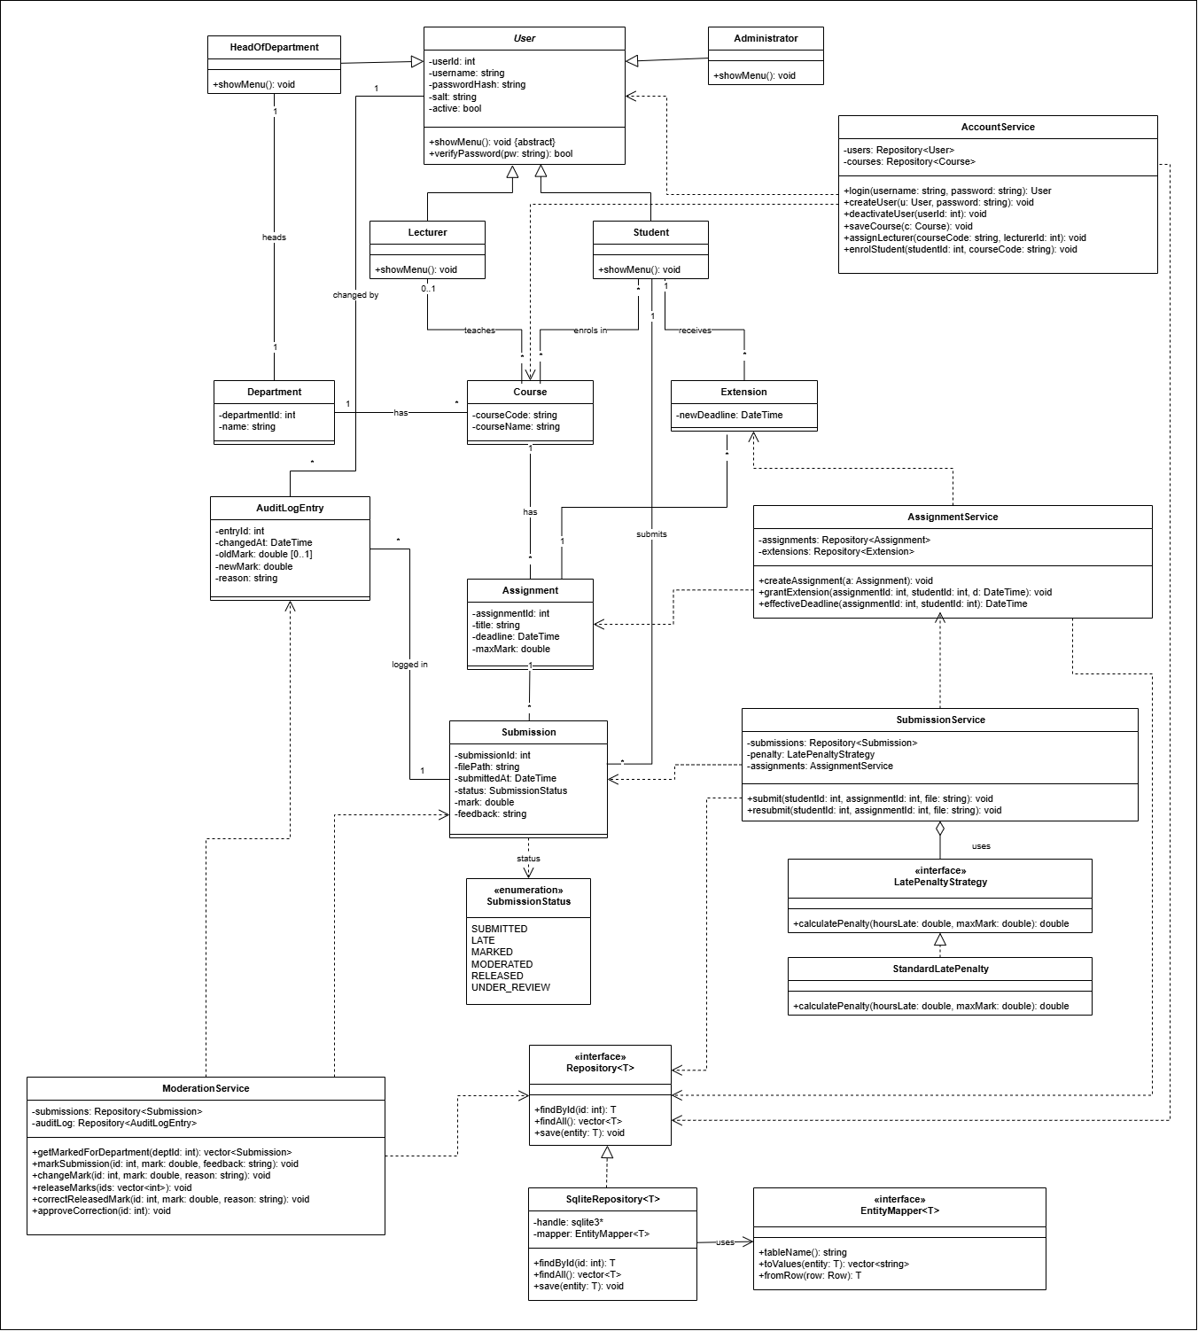

3.1 Design patterns
Pattern | Where it is used | Why it was chosen
Strategy | LatePenaltyStrategy (interface) and StandardLatePenalty. SubmissionService uses the strategy to calculate the penalty. | The HoD’s late rule may change. A new rule is a new class and SubmissionService does not change.
Repository (with Data Mapper) | Repository, SqliteRepository and EntityMapper | Services never see SQL. SQLite can be replaced, or a fake repository used in tests, without changing the services. EntityMapper keeps the table and column details of each entity out of the repository code.
Polymorphism (Template-style base class) | Abstract User with showMenu() in four subclasses | Role-based access is done by the object type. The login code calls showMenu() and does not check the role with if statements.

How the late-penalty Strategy works
SubmissionService finds the effective deadline from AssignmentService, works out the hours late, and calls calculatePenalty(hoursLate, maxMark). StandardLatePenalty returns 10% of the maximum mark for each started 24 hours, and the full maximum mark (a mark of zero) after 72 hours. A submission exactly 24, 48 or 72 hours late falls in the lower band, as set in the SRS assumptions.

3.2 SOLID principles
Principle | How the design follows it
Single responsibility | Each service has one job: accounts, assignments, submissions, or moderation. Mappers only convert between objects and rows.
Open/closed | New penalty rules are added as new LatePenaltyStrategy classes. New entities need a new EntityMapper only.
Liskov substitution | Any User subclass can be used where a User is expected. Any Repository implementation can replace SqliteRepository.
Interface segregation | Interfaces are small: LatePenaltyStrategy has one operation, EntityMapper has three, Repository has a few.
Dependency inversion | Services depend on Repository and LatePenaltyStrategy, not on SQLite or StandardLatePenalty.

4. Behavioural models

4.1 Submission state machine
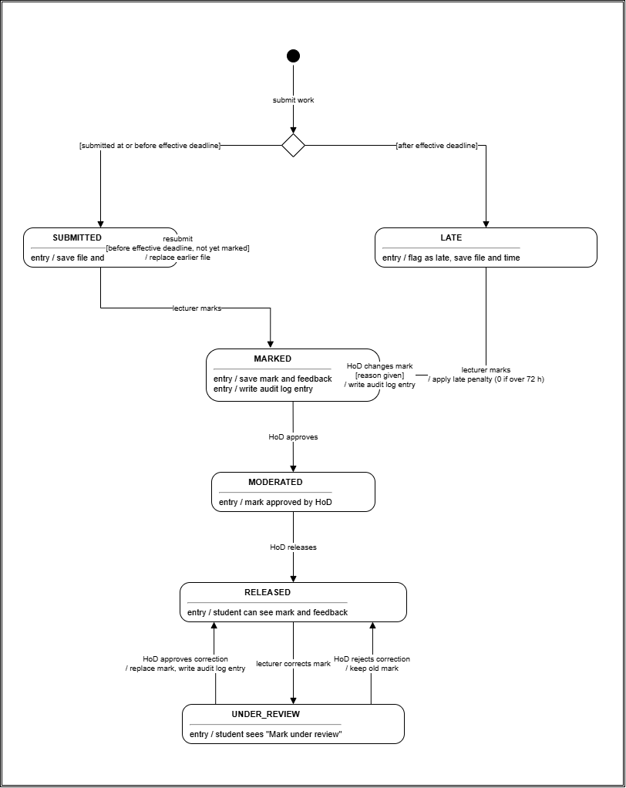
A submission can be seen by a student only in the RELEASED state. In UNDER_REVIEW the student sees only the notice.

4.2 Activity diagram
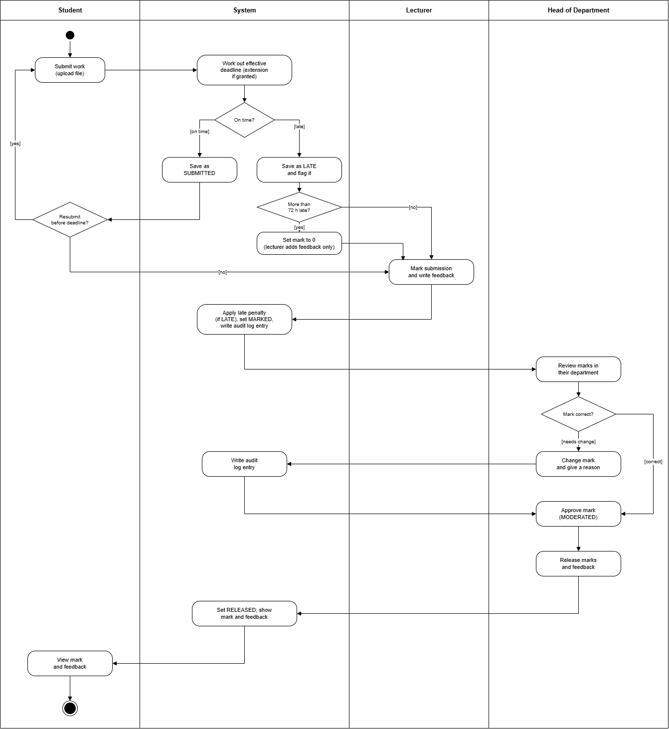
The diagram follows the process from submission to released mark across four swimlanes: Student, System, Lecturer and Head of Department.

4.3 Sequence diagram: Submit assignment
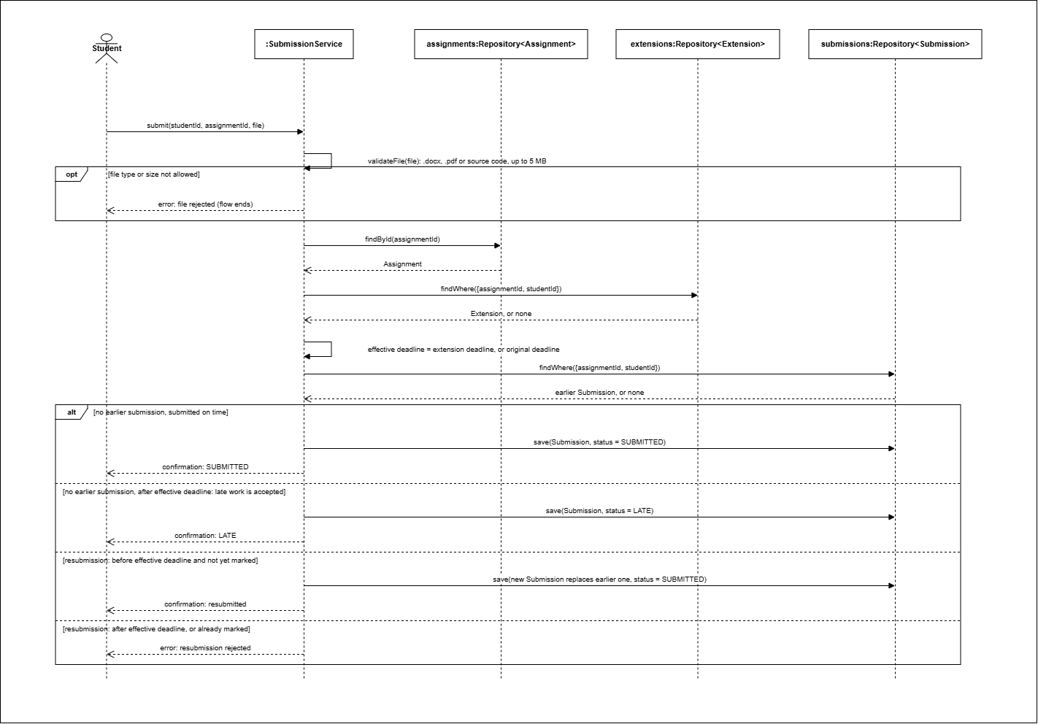

4.4 Sequence diagram: Moderate and release marks
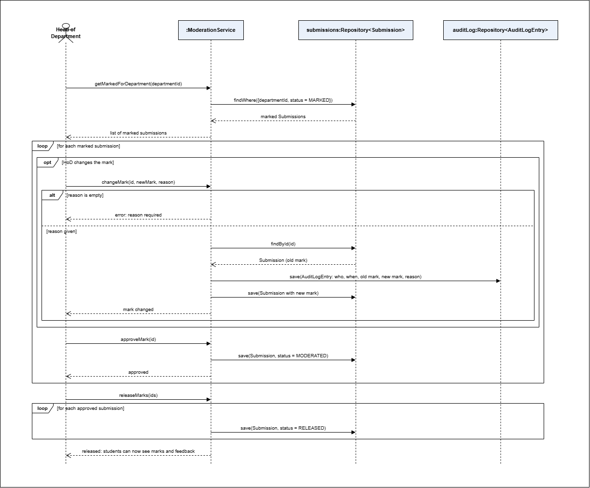

5. Database design
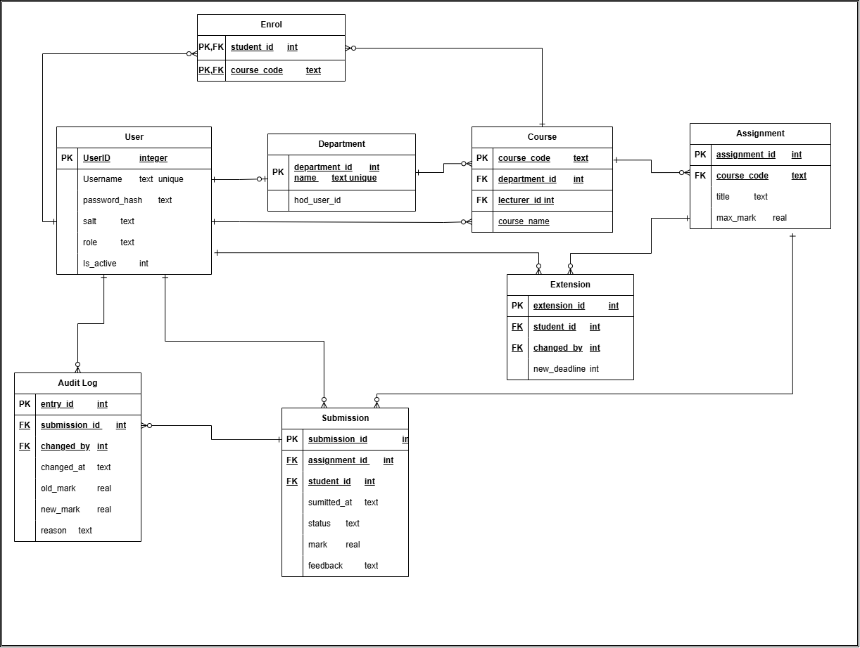

5.1 Normalisation
Normal form | How the design meets it
First (1NF) | Every column holds one value. There are no repeating groups. Many-to-many data (enrolment) is in its own table.
Second (2NF) | The only table with a composite key is enrol, and it has no other columns, so there are no partial dependencies. All other tables have a single-column key.
Third (3NF) | No non-key column depends on another non-key column. The department name is stored only in department, and the lecturer’s details only in user. The effective deadline and the late penalty are calculated by the services and not stored.

5.2 Data dictionary

user
Column | Type | Constraints | Description
user_id | INTEGER | PK, autoincrement | Unique user number
username | TEXT | NOT NULL, UNIQUE | Login name
password_hash | TEXT | NOT NULL | Salted hash of the password
salt | TEXT | NOT NULL | Random salt for this user
role | TEXT | NOT NULL, CHECK in (ADMINISTRATOR, LECTURER, HOD, STUDENT) | Role of the user
is_active | INTEGER | NOT NULL, default 1, CHECK 0 or 1 | 0 means deactivated

department
Column | Type | Constraints | Description
department_id | INTEGER | PK, autoincrement | Unique department number
name | TEXT | NOT NULL, UNIQUE | Department name
hod_user_id | INTEGER | UNIQUE, FK to user | The Head of Department

course
Column | Type | Constraints | Description
course_code | TEXT | PK | Course code
course_name | TEXT | NOT NULL | Course name
department_id | INTEGER | NOT NULL, FK to department | Owning department
lecturer_id | INTEGER | FK to user, may be NULL | Lecturer teaching the course

enrol
Column | Type | Constraints | Description
student_id | INTEGER | PK part, FK to user | Enrolled student
course_code | TEXT | PK part, FK to course | Course

assignment
Column | Type | Constraints | Description
assignment_id | INTEGER | PK, autoincrement | Unique assignment number
course_code | TEXT | NOT NULL, FK to course | Course of the assignment
title | TEXT | NOT NULL | Assignment title
deadline | TEXT | NOT NULL | Original deadline
max_mark | REAL | NOT NULL, CHECK greater than 0 | Maximum mark

extension
Column | Type | Constraints | Description
extension_id | INTEGER | PK, autoincrement | Unique extension number
assignment_id | INTEGER | NOT NULL, FK to assignment | Assignment extended
student_id | INTEGER | NOT NULL, FK to user | Student who received it
new_deadline | TEXT | NOT NULL | Extended deadline
UNIQUE (assignment_id, student_id): a student has one extension for each assignment.

submission
Column | Type | Constraints | Description
submission_id | INTEGER | PK, autoincrement | Unique submission number
assignment_id | INTEGER | NOT NULL, FK to assignment | Assignment
student_id | INTEGER | NOT NULL, FK to user | Student
file_path | TEXT | NOT NULL | Location of the saved file
submitted_at | TEXT | NOT NULL | Time of submission
status | TEXT | NOT NULL, default SUBMITTED, CHECK in the six statuses | Life cycle state
mark | REAL | CHECK 0 or more, may be NULL | Current mark
feedback | TEXT | may be NULL | Lecturer’s written feedback
UNIQUE (assignment_id, student_id): a resubmission replaces the earlier row.

audit_log
Column | Type | Constraints | Description
entry_id | INTEGER | PK, autoincrement | Unique entry number
submission_id | INTEGER | NOT NULL, FK to submission | Submission whose mark changed
changed_by | INTEGER | NOT NULL, FK to user | Who changed the mark
changed_at | TEXT | NOT NULL | When it changed
old_mark | REAL | may be NULL | Mark before the change
new_mark | REAL | NOT NULL | Mark after the change
reason | TEXT | NOT NULL, CHECK not blank | Reason for the change

5.3 SQL schema
PRAGMA foreign_keys = ON;
-- User: one table for all four roles
CREATE TABLE user (
user_id INTEGER PRIMARY KEY AUTOINCREMENT,
username TEXT NOT NULL UNIQUE,
password_hash TEXT NOT NULL,
salt TEXT NOT NULL,
role TEXT NOT NULL CHECK (role IN ('ADMINISTRATOR', 'LECTURER', 'HOD', 'STUDENT')),
is_active INTEGER NOT NULL DEFAULT 1 CHECK (is_active IN (0, 1))
);
CREATE TABLE department (
department_id INTEGER PRIMARY KEY AUTOINCREMENT,
name TEXT NOT NULL UNIQUE,
hod_user_id INTEGER UNIQUE REFERENCES user (user_id)
);
CREATE TABLE course (
course_code TEXT PRIMARY KEY,
course_name TEXT NOT NULL,
department_id INTEGER NOT NULL REFERENCES department (department_id),
lecturer_id INTEGER REFERENCES user (user_id)
);
-- Link table: student and course (many-to-many)
CREATE TABLE enrol (
student_id INTEGER NOT NULL REFERENCES user (user_id),
course_code TEXT NOT NULL REFERENCES course (course_code),
PRIMARY KEY (student_id, course_code)
);
CREATE TABLE assignment (
assignment_id INTEGER PRIMARY KEY AUTOINCREMENT,
course_code TEXT NOT NULL REFERENCES course (course_code),
title TEXT NOT NULL,
deadline TEXT NOT NULL, -- ISO 8601: YYYY-MM-DD HH:MM:SS
max_mark REAL NOT NULL CHECK (max_mark > 0)
);
CREATE TABLE extension (
extension_id INTEGER PRIMARY KEY AUTOINCREMENT,
assignment_id INTEGER NOT NULL REFERENCES assignment (assignment_id),
student_id INTEGER NOT NULL REFERENCES user (user_id),
new_deadline TEXT NOT NULL,
UNIQUE (assignment_id, student_id)
);
CREATE TABLE submission (
submission_id INTEGER PRIMARY KEY AUTOINCREMENT,
assignment_id INTEGER NOT NULL REFERENCES assignment (assignment_id),
student_id INTEGER NOT NULL REFERENCES user (user_id),
file_path TEXT NOT NULL,
submitted_at TEXT NOT NULL,
status TEXT NOT NULL DEFAULT 'SUBMITTED' CHECK (status IN ('SUBMITTED', 'LATE', 'MARKED', 'MODERATED', 'RELEASED', 'UNDER_REVIEW')),
mark REAL CHECK (mark >= 0),
feedback TEXT,
UNIQUE (assignment_id, student_id)
);
CREATE TABLE audit_log (
entry_id INTEGER PRIMARY KEY AUTOINCREMENT,
submission_id INTEGER NOT NULL REFERENCES submission (submission_id),
changed_by INTEGER NOT NULL REFERENCES user (user_id),
changed_at TEXT NOT NULL,
old_mark REAL,
new_mark REAL NOT NULL,
reason TEXT NOT NULL CHECK (length(trim(reason)) > 0)
);
CREATE INDEX idx_course_department ON course (department_id);
CREATE INDEX idx_assignment_course ON assignment (course_code);
CREATE INDEX idx_submission_student ON submission (student_id);
CREATE INDEX idx_audit_submission ON audit_log (submission_id);

5.4 Mapping of classes to tables
Class | Table | Difference and justification
User, Student, Lecturer, HeadOfDepartment, Administrator | user | One table for the whole hierarchy, with a role column (single-table inheritance). The subclasses add no attributes, so separate tables would only add joins. The role column lets the repository create the correct subclass.
Department | department | The heads association is stored as hod_user_id.
Course | course | The teaches association is stored as lecturer_id, because a course has at most one lecturer. The has association is stored as department_id.
Student enrols in Course | enrol | A many-to-many association becomes its own table with a composite key.
Assignment | assignment | The has association is stored as course_code.
Extension | extension | The receives association is stored as student_id and the has association as assignment_id.
Submission | submission | The submits and has associations are stored as student_id and assignment_id. SubmissionStatus becomes a CHECK constraint.
AuditLogEntry | audit_log | The logged-in and changed-by associations are stored as submission_id and changed_by.
Services, LatePenaltyStrategy, Repository, EntityMapper | none | These hold behaviour and have no data to store.

